Custom Software Solutions for Benefits Consulting

Leading a Struggling team to Launch Benefits solution on-time

THE CLIENT:
A global consulting leader in health and benefits who delivers innovative solutions for clients in over 130 countries. They are at the forefront of digital healthcare solutions, delivering insights and designing strategies and platforms to enable companies to stay ahead of the changing health and welfare needs of their employees. The brokers leverage their company’s wealth of data and tools to design client programs focused on delivering benefits to improve employee health and well-being at a competitive price.

THE BUSINESS NEED:
As a leader in the employee benefits brokerage market, this company continuously enhances the platforms used by their thousands of brokers world-wide who create and manage benefit plans for their clients. Delivering on a world-wide scale means creating platforms that are flexible to meet country specific needs while providing aggregation and metrics at an enterprise level with access to specialists and tools specific to the local markets. To enable their brokers in the US to stay ahead of the rapidly changing needs of that market, the client envisioned a new broking platform. The new platform was designed to minimize the amount of time the broker spent managing benefit plan data and maximize their consulting ability through a new dashboard providing benchmarks comparisons, carrier rate trends, and plan comparisons across similar industries and client sizes.
The client had implemented a multi-stream agile project team containing 5 teams working together to bring the new platform to life. The project had been underway for 3 months and one of the workstreams was in trouble.

WHAT GENECA DID:
Geneca partnered with the client’s project stakeholders and the agile delivery teams to take over the reporting and analytics workstream. When we joined the project, it was in flight and the team was 3.5 months away from their product launch. The analytics workstream had stalled, development had not started, and the workstream was in a ‘red’ state after 3 months of work. We were asked to dive in, take over the workstream and get things back on track so that project could make the planned launch date.
The workstream included the integration of a 3rd party tool into the new broking platform and the creation of a dashboard and set of configurable charts and exports to deliver the new consulting insights. Geneca was asked to provide leadership and all of the deliverables except software development which was supplied by the 3rd party tool. We managed sprints using Atlassian’s JIRA suite and wrote user stories in Gherkin syntax.

THE SOLUTION:
Geneca quickly assessed what was needed and took 4 immediate steps to activate the workstream.

1. UNBLOCK THE STORY WORK
We confirmed scope with the business stakeholders and set up a series of story sessions so that they were ready to go for the upcoming sprint planning session. Since the timeline was short, we needed to leverage as much of the ‘out-of-the box’ tool functionality as possible so we created initial mockups that accurately reflected the capabilities of the third-party tool. These mockups served as an initial starting point for our story sessions and helped the business to articulate their vision.
2. DEFINE 3RD PARTY INTEGRATION TOOL
There are different ways that a 3rd party analytics tool can be integrated into an application. While there had been many unresolved conversations and lengthy discussions, no progress had been made toward making a decision. From our previous experience with 3rd party integrations, we knew we needed to create a decision approach to help the team. We led meetings to identify integration options and weighed the resulting user experience with the resource availability and timeline dependencies for each team involved. With what they needed to make the decision, they select an approach, unblocking the work stream for the UI design team.
3. REFOCUS UI DESIGN WORK
A different 3rd party design firm was responsible for the new broker platform UI design. Without a prior decision on the integration approach, they had been free to design without any implementation constraints. Once we helped the program team define the 3rd party tool integration, we were able to take the approach to the design firm and re-focus their work on designs that could be delivered. We also coordinated the mockups presented to the business in each story session with the UI design team so that these workstreams were now in alignment.
4. PROVIDE VISBILITY TO CROSS-TEAM DEPENDENCIES
Once development was underway, we needed to create visibility to our scope and identify the tasks in our workstream dependent on the completion of others. The greatest dependency was between our developers who were creating the reports and the internal team who were building queries for the data needed to generate them. We created a repeatable, dependable process for communicating that work. We also opened up communication with cross-teams so that we could coordinate our sprint work across all of the streams without spending too much time in meetings.

THE RESULTS:
Within 2 weeks, Geneca enabled the client to start development on this project though it had been stalled for months. Shortly after, we enabled the UI design team to build designs reflective of the capabilities that could be delivered by the 3rd party tool. Within one month of joining the project, we were able to successfully deliver the first showcase. After 6 weeks, we turned the workstream status from ‘Red’ to ‘Green’.
We established role definition and repeatable process for chart and query data mapping. We also moved work around effectively for improved resource use. We organized and facilitated sessions that allowed the business to become more familiar with what the tool could and could not do, which sped up story design and eliminated surprises and re-work. We integrated work across the 5 workstreams to provide visibility and completed deliverables that instilled increased confidence and trust in the analytics team.
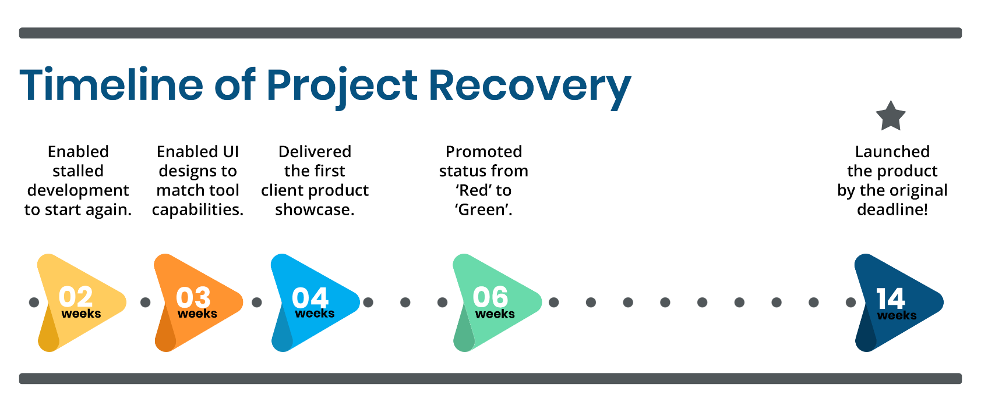

Ultimately, Geneca provided the client with what they needed to get the project back on track and successfully launch the product by their deadline.

ABOUT GENECA
Geneca is a custom software consulting company with 20+ years of experience using advanced strategies to help clients stay ahead of their competition. At Geneca, we know that software isn’t one size fits all. We explore your unique needs and identify the right solution to accomplish your goals. We create lasting, solid partnerships with our clients and work together to design revolutionary products that engage users, transform industries, and evolve with your business.
Let’s Talk! Email us at Sales@geneca.com Call us at (630) 599-0900

