Custom Software Solutions for Financial Services

modernized financial mobile app improves OUTDATED user experience for customers

THE CLIENT:

Our client acts as a bridge between those who need trucking services and those who provide them. They match companies that need to transport large loads with long-haul companies that have the capacity and experience to carry them.
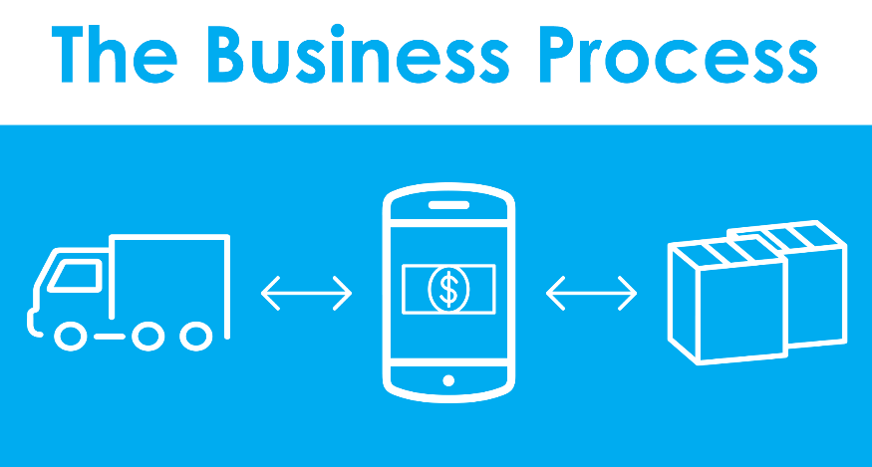

With the help of a mobile application, they allow companies to search for matches and learn about their options. Once the companies find a match they approve of, our client facilitates the cash flow between both parties.

THE BUSINESS NEED:
Our client was using a dated mobile app riddled with bugs. As a result, our client spent time and resources finding workarounds, and their customers suffered a poor user experience.
Our client was in search of a new, updated app that would allow them to handle invoicing, payments, and more. They wanted a new app that would work on IOS and Android operating systems. Our client already had a team lined up to build the IOS version of the app, but they still needed an experienced company to design and develop the app for Android operating systems.
WHAT GENECA DID:
Due to differences in IOS and Android development environments, it wasn’t possible to create two identical versions of the app. Therefore, the biggest obstacle for the team was translating IOS-centric design to an Android application. We worked with our client’s team of developers to successfully:
- Build a new app in Kotlin from scratch with Android Studio and Software Development Kit
- Ensure cohesion between both IOS and Android apps with similar branding and user experiences
- Create a version of a document scanner that would perform the same tasks as the built-in IOS feature
- Modernize the app while retaining the feel of the original one

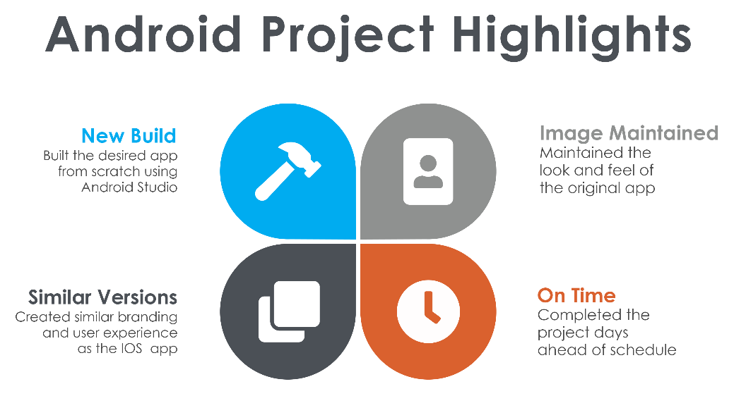

THE RESULTS:
By having transparent conversations, prior research, and a detailed technical plan, our team was able to anticipate potential issues or roadblocks and navigate them quickly and efficiently.
App development went smoothly from start to finish, allowing our team to finish five days ahead of schedule
Our client was extremely pleased with the finished product. Because of our transparent communication, polished mobile application, and ability to deliver on time, our client has already recruited our team for future work, and we are excited to continue to help them grow.

ABOUT US
Geneca is a custom software consulting company with 20+ years of experience using advanced strategies to help clients stay ahead of their competition. At Geneca, we know that software isn’t one size fits all. We explore your unique needs and identify the right solution to accomplish your goals. We create lasting, solid partnerships with our clients and work together to design revolutionary products that engage users, transform industries, and evolve with your business.
Let’s Talk! Email us at Sales@geneca.com Call us at (630) 599-0900

