Custom Software Solutions for Property Management

“MIND THE GAP”: Securing user PERMISSIONS ACROSS MULTIPLE APPLICATIONS

THE CLIENT:
The company is a global investment and consulting leader, specializing in commercial real estate and property management. Their consultants serve organizations of all sizes, across industries, all over the world. In the course of their work, the consultants use several different business applications in order to collect, analyze, model, and report on their client’s property data.

THE BUSINESS NEED:
The business applications used by the consultants had been acquired over several years. These applications had been integrated along the way to allow the property data used by more than one application to be shared in a secured data architecture and environment. he client also had designed and was in the process of implementing a custom security and authentication framework to manage the user access and permissions across all of their applications. However, not all of the legacy applications supported the new framework. Consultants had to login separately to some of the legacy applications, creating a potential ‘gap’ between the permissions in the legacy application and the permissions in the security framework. While a multi-year plan was in place to sunset or upgrade the legacy applications, a custom security solution was needed to ‘mind the gaps’ during the plan’s rollout.

WHAT GENECA DID:
Geneca designed a custom approach and solution which included 4 components for each legacy application:
1. Analyzed the user permissions and defined security gap’ criteria
We analyzed the user permissions in the legacy application so they could be compared and ‘matched’ to the permissions in the security framework. We clarified that a security gap happens as a mismatch between the user permissions in the legacy application and security framework. As a result, we identified a gap in the legacy application as well as some potential gaps for analyst review due to specific user configurations.
2. Creation of a custom security application
We designed, developed, and implemented a custom software solution which gathered each user’s permissions in the legacy application and, using the gap criteria defined, performed a comparison to the security framework. This generated the Gap Results – a list of users whose permissions had gaps and potential gaps to be filled.
3. Reviewed the Gap Results and finalized the set of security gaps to be filled
We reviewed and validated the previously generated Gap Results list. In addition, we analyzed each user with a ‘potential gap’ and determined if it were a gap we needed to fill or a permission update for the security framework.
4. Closed the existing gaps and automated the solution until completion of the legacy application
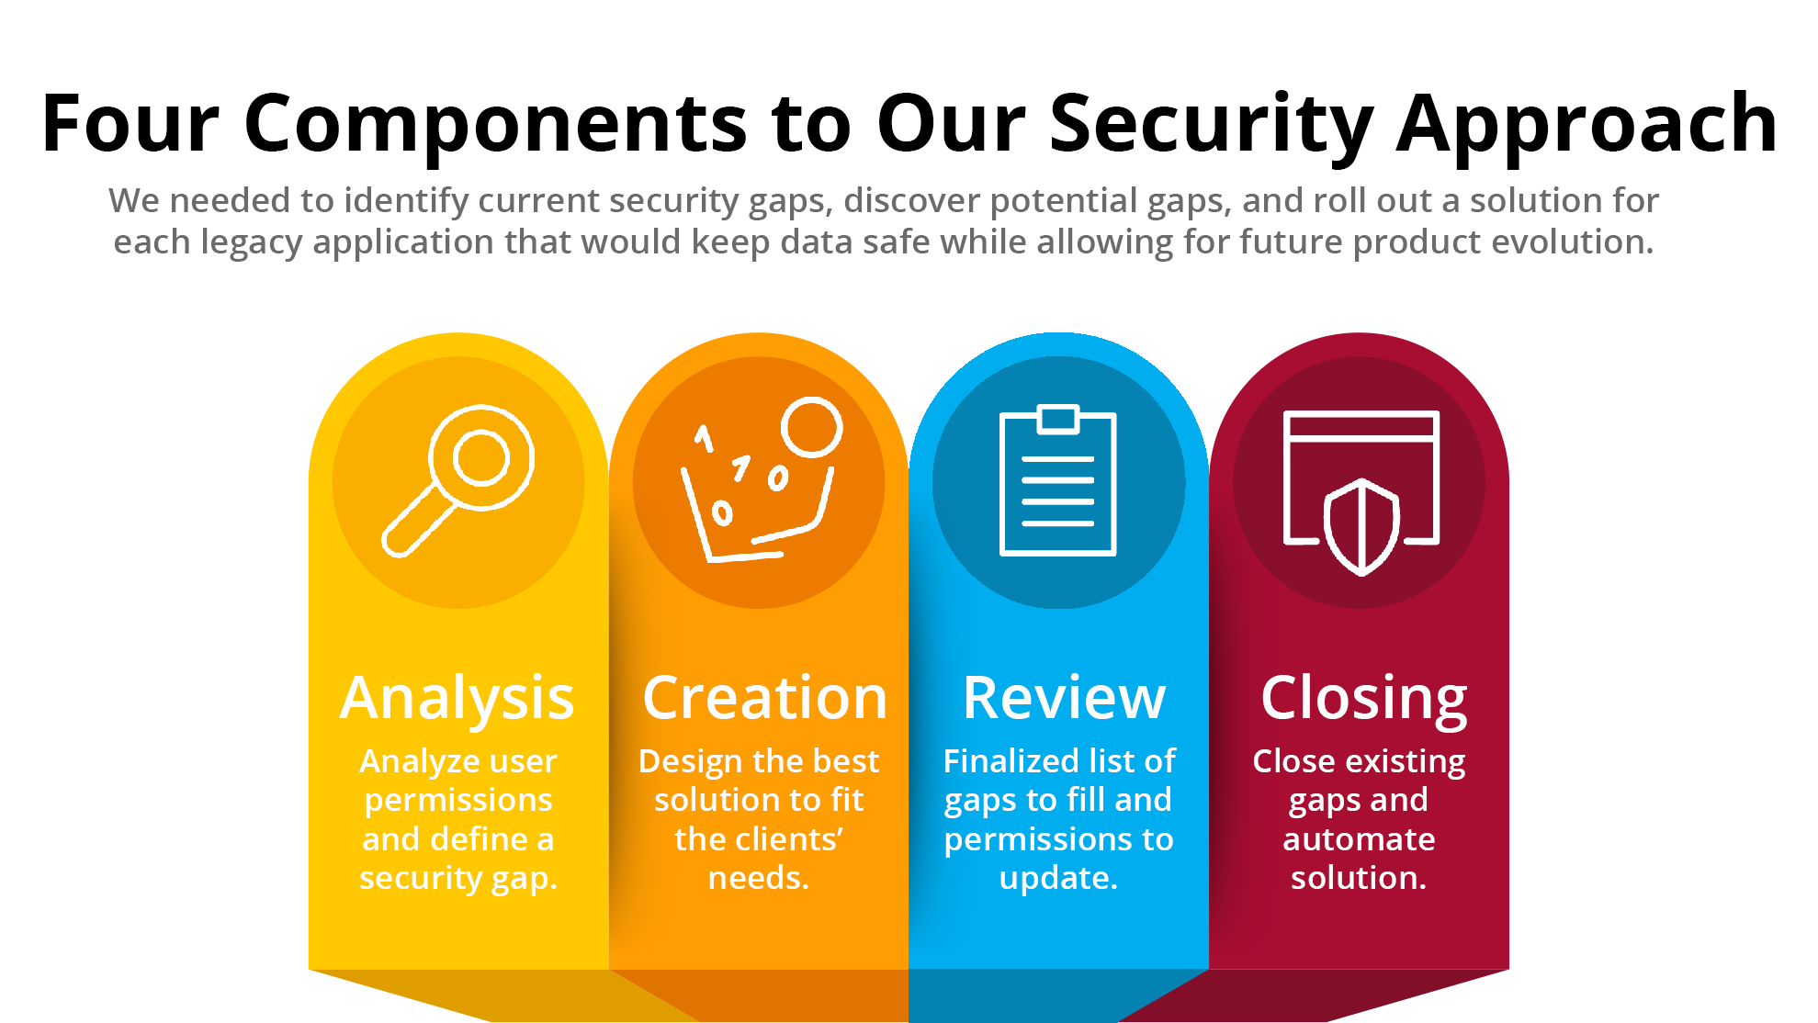
The custom security application used the initial Gap Results list to ‘close’ all of the existing gaps. User permissions in the legacy application were updated to match the permissions in the security framework. We automated the solution with a service that was invoked when new users were added to the legacy application so that their permissions would be in alignment with the security framework.

THE RESULTS:
A custom security service that aligned legacy permissions and roles with the new authentication and security framework!
Equally important to the client was the fact that this solution enabled them to upgrade or retire the legacy applications over time. It leveraged the existing permissions in the legacy applications and did not require trying to change the aging applications to try to force fit them into the new security framework – that saved time and money.
It afforded a smoother transition for the consultants and allowed an evolution to the new security framework with a globally phased rollout plan designed to accommodate and adjust for changes over time.
Let’s Talk! Email us at Sales@geneca.com Call us at (630) 599-0900

