Custom Software Solutions for B2B Marketing

Helping our partner break into new tech and win business

THE CLIENT:
This B2B marketing agency brings customer-focused solutions to mid-sized and enterprise businesses around the world. With diverse teams of top talent, this client helps to enhance the customer experience in a variety of ways. Their clients benefit from services like digital marketing, app development, customer data analysis, print materials, and video production. We help this client deliver projects with a focus on digital transformation and emerging technologies.

THE BUSINESS NEED:
Though they had a strong in-house IT team, the client needed additional developers to support their largest single project. The business had had bad luck with other technology vendors in the past and was looking for a trustworthy partner that could provide top talent and consistently deliver on projects. They needed software developers that could ramp up fast, learn new technologies, and blend with existing teams of full-time employees.
The business’ client sold and manufactured industrial equipment on a large scale for use in the safety and agricultural industries. The goal was for us to help create and maintain a Sitecore e-commerce system. In addition, our client had other clients that relied on Sitecore technology and wanted to leverage our expertise to support them and provide additional value in the future.

WHAT GENECA DID:
We joined the existing team and started proving ourselves right away. Though we were new to Sitecore technology, our developers picked it up fast. In a short time, we were running blended projects for the client and one Genecian had earned their way to tech lead over more experienced team members.

We established a Sitecore e-commerce system for one client and assisted another in security enhancements. We condensed subdomains to one central site and helped ease hosting concerns with a PAAS deployment to Microsoft Azure. In addition, we brought the client one step closer to achieving future goals, evolving the technology to better align with the ability to host sites internationally and translate multiple languages.

THE RESULTS:
Our Genecians provided value to this client right from the start, learning fast and propelling projects forward. We helped them break into Sitecore technology and demonstrate their value as a leader in digital transformation to their clients. Our client was able to leverage this work to entice and secure their largest client to date.
Our knowledge and expertise in both emerging technologies and project leadership allowed this client to help their own clients meet specific technology goals, be better prepared for future evolution, and stand out as industry leaders. We helped our client win new business and solidify their reputation as an agency with the capabilities to deliver cutting-edge solutions.

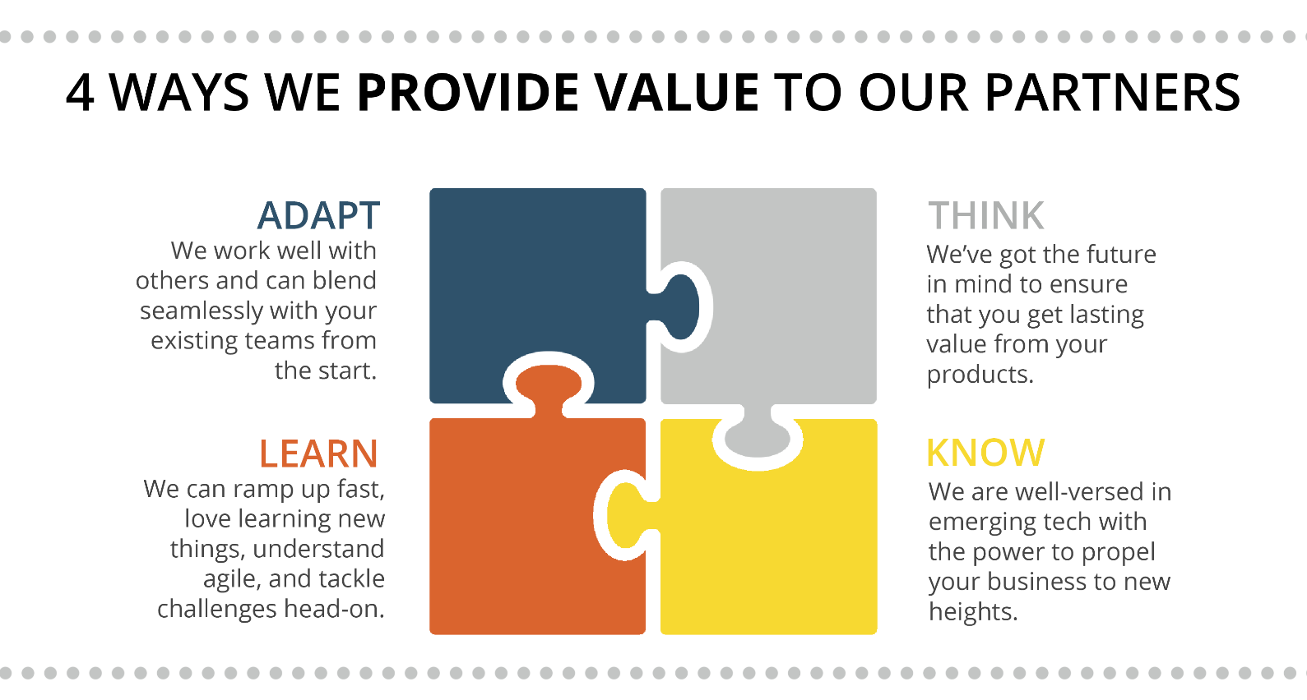

ABOUT GENECA
Geneca is a custom software consulting company with 20+ years of experience using advanced strategies to help clients stay ahead of their competition. At Geneca, we know that software isn’t one size fits all. We explore your unique needs and identify the right solution to accomplish your goals. We create lasting, solid partnerships with our clients and work together to design revolutionary products that engage users, transform industries, and evolve with your business.

Let’s Talk! Email us at Sales@geneca.com Call us at (630) 599-0900

