Custom Software Solutions for Transportation

IMPROVING LOYALTY WITH A REWARDS MOBILE APP

THE CLIENT:
The client is a multi-national conglomerate of pension companies moving into a new space—transportation. After being granted the first ever lease of an existing toll road three years previously, the company now desired a way to improve the experience for their users through creation of a loyalty app. This app will allow frequent users to receive a variety of rewards for traveling the toll road with a goal of increasing overall travel and improving customer satisfaction with the toll road operations.

THE BUSINESS NEED:
The client already utilized Geneca’s services to create the software to manage their existing tolling functions including ordering a vehicle transponder and paying tolls online. They wished to move forward with a new offering in the form of a mobile and desktop application that would allow users to opt into a reward program. Overall, this client desires careful growth balancing a cautious spend of their pensioner dollars with gains made by staying technologically current for their clients.
Through an analysis of user behavior data, the client learned that many of their customers would use the toll road in the morning to arrive at work on time but would avoid the toll road during the evening commute. They hoped to use rewards to increase use of the toll road for after work travel. Additionally, they hoped to use rewards during holiday weekends for recreational users traveling around the area through a holiday reward offer. An opt-in app would also allow the company to gather additional data points about users that could not be collected in the existing operations and could identify better customer service opportunities for the company.
WHAT GENECA DID:
In order to enable the company to create a loyalty app for their customers, Geneca worked closely with the company stakeholders to analyze existing data for potential reward offers. Upon completion of the analysis, the team had a series of loyalty promotions from frequent monthly travel to birthday to special event rewards that made sense to include in a first release of a mobile application.
Since both Geneca and the client understood that as new data was collected the client would want to design new types of loyalty offers, we created a very flexible administrative interface to allow for a wide range of criteria to utilize in creation of a reward. Although the initial offering would be a discount of future trips on the toll road, the software was configured to allow for gift cards as a future reward, as well.
For the loyalty customers, the design included a dashboard with a custom speedometer inspired widget to showcase the monthly travel, a full year graphical representation of a user’s travel, and easy to understand loyalty rewards. Users who enrolled in the loyalty program would not only gain rewards but would also have new ways to see their existing travel activities. At a glance, customers can see and update account information, see live travel activity, and view an overview of their monthly travel and rewards through the dashboard.

THE RESULTS:

Upon launch of the loyalty program, initial adoption grew month over month with minimal advertising spend. The program reached 2,500 active users within three months of launch. Travel over the first six months by users enrolled in the program increased, exceeding the client’s expectations. The client continues to utilize data collected by the system with new loyalty promotions to increase customer use of the toll road and deliver better optimization of data and better responsiveness to customer needs.
Additionally, the client continues to improve general operations through the data collected within the app. Calls into customer service decreased after three months of app usage as customers could easily see their activity and match it to monthly bills without a need to connect with service reps for questions. Cutting down on these calls allowed customer service team members to focus on other work items and resulted in employees’ satisfaction with their job to increase as they spend less time on customer confusion calls.
The initial cost of the mobile app was recouped within the first three months of use, allowing the client to begin planning for the next technological advancement to continue to improve the experiences of their customers and employees.

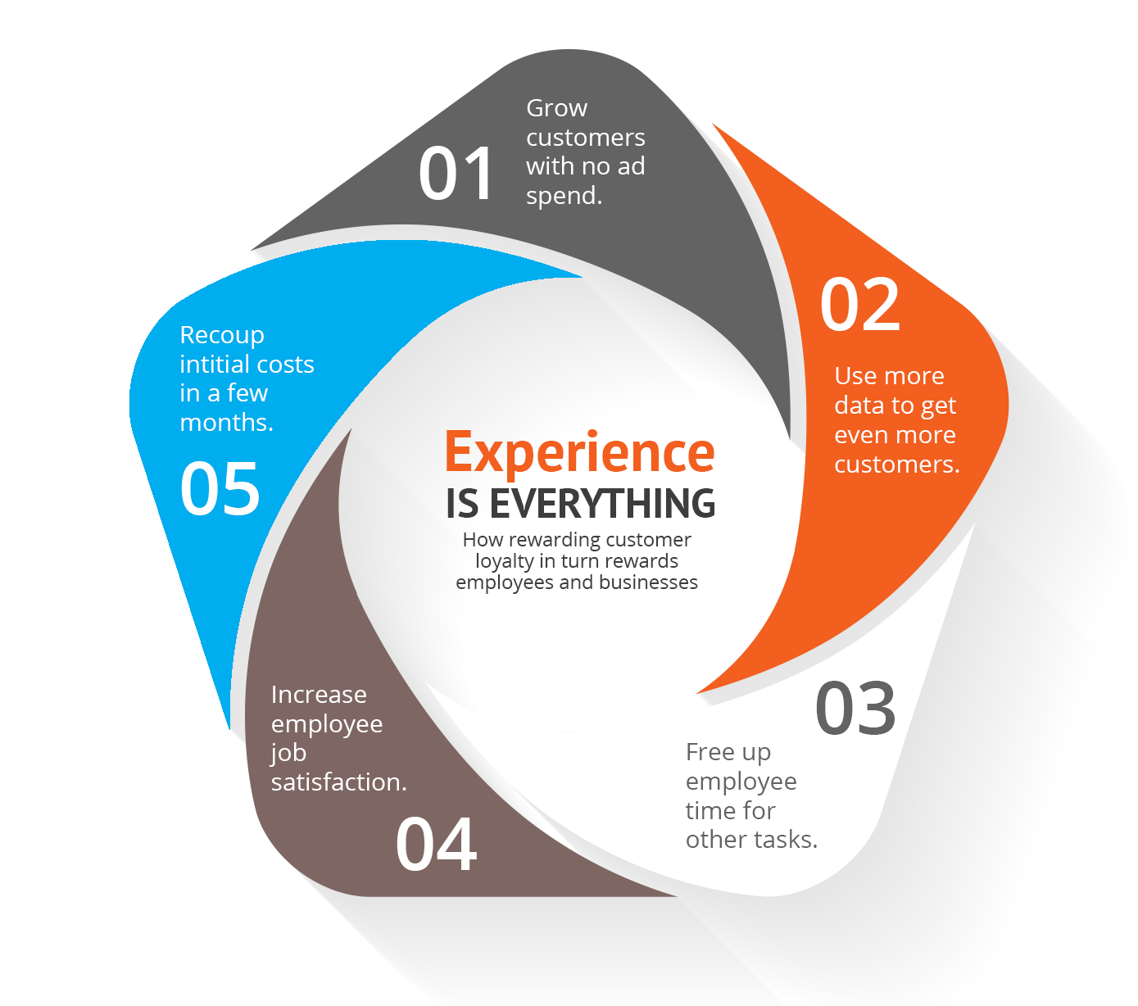

Let’s Talk! Email us at Sales@geneca.com Call us at (630) 599-0900

