Custom Software Solutions for Real Estate

GROWING competitive advantage with More reporting and data flexibility

THE CLIENT:

Our client is a global leading investment and consulting firm, specializing in real estate, that caters to organizations of all sizes, across industries, all over the world. Our client wanted a more cost-effective hosting solution and a new application framework for one of their large government agency clients. Their client needed a solution for managing extensive documentation as well as financial and operational data for hundreds of facilities.

THE BUSINESS NEED:
The client was ready for another evolution on a custom product that Geneca created, maintains, and enhances for them. This application is used to help track data, activity, and documentation on various facilities projects and provides a serious competitive advantage in the real estate space for our client. The client was looking for additional flexibility and control around gathering and reporting on data, a major function of this application.

However, the client needed to achieve this goal while keeping document management within existing SharePoint portals. Blending some features of the existing financial application and SharePoint portals with a new, enhanced financial application all while preserving a positive user experience posed a unique challenge.

WHAT GENECA DID:
We pivoted from our original plan for enhancing reporting capabilities to one that would still permit the application to use SharePoint for document storage and management. We designed a new method that would provide value right away while setting the stage for better reporting in the future and allowing for the clients to transition easily to an application with a new look and feel. In this release, Geneca:

- Transitioned the application from an EAV data model to a transactional one
- Redesigned admin functions, site navigation, and the approach to data security
- Created a user dashboard consisting of customizable charts showing important data
- Improved and streamlined the current data entry experience for all users

THE RESULTS:
With this latest product evolution and release, the client noted improved data management and tracking, simplified data entry, new administrative functions, a superior user interface, and a user-friendly customizable dashboard. These features provided the client with a way to visualize and represent data in any way they want while maintaining security and streamlining data collection for thousands of users.
As we move forward with the next phase of work, the database updates made in this release position us for a smooth transition to a more secure framework for the application and the ability to add functionality to existing reporting tools. Keeping the future in mind, we were able to reduce any rework that may have been necessary once we are ready to build the next phase.
Super users can take advantage of enhanced control with new administrative functions located in a central place within the application. They are able to learn and implement all of the new features while they train additional users, improving the chances for strong user adoption and a smooth product rollout.
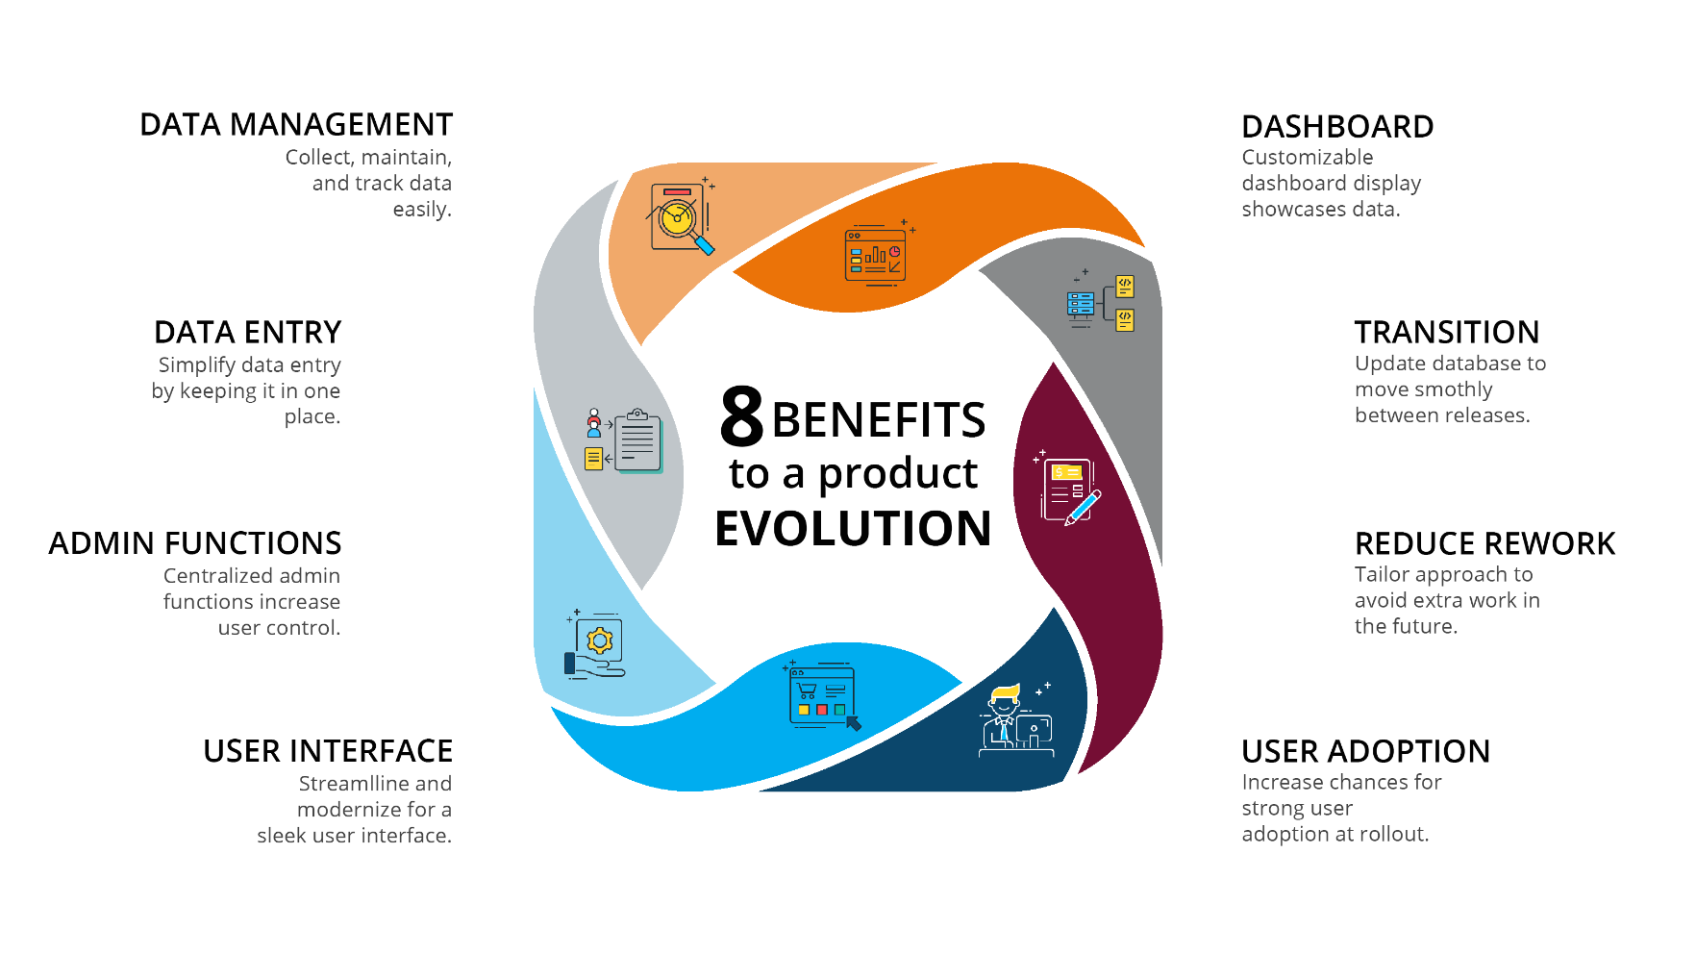

ABOUT GENECA
Geneca is a custom software consulting company with 20+ years of experience using advanced strategies to help clients stay ahead of their competition. At Geneca, we know that software isn’t one size fits all. We explore your unique needs and identify the right solution to accomplish your goals. We create lasting, solid partnerships with our clients and work together to design revolutionary products that engage users, transform industries, and evolve with your business.
Let’s Talk! Email us at Sales@geneca.com Call us at (630) 599-0900

