Custom Software Solutions for Entrepreneurs

EMPOWERING FUTURE GENERATIONS WITH MOBILE MONEY MANAGEMENT TOOLS

THE CLIENT:
Our client dedicated his time and talent to teaching financial planning and management to kids through his own book. The children’s book makes money management accessible and even fun for children to learn and use in their everyday lives. With the help of his book, our client hopes to give kids the chance to start saving, earning, and managing their finances early in their lives, which will ultimately help them achieve financial independence in the future.

THE BUSINESS NEED:
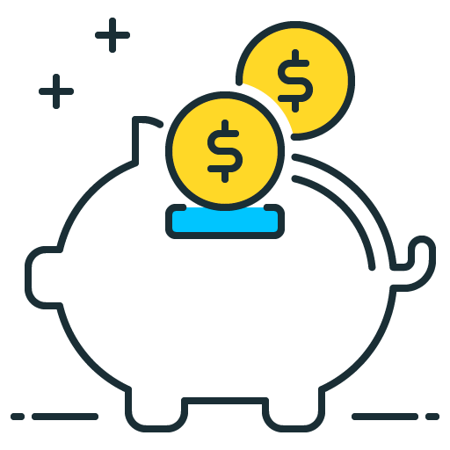
The book written by our client creates the foundation for financial planning and management, but it doesn’t give kids the means or tools to start applying that knowledge. That’s where we come in. Our client wanted to create an app to go hand in hand with his book. The app would provide a visual representation of how money management works by including three different accounts for children to use:
- Planned expenses per month
- Planned income per month
- Planned income over a variable period of time
The app allows a parent to set up a group with themselves and each of their kids. By doing so, the parents and the children can visualize and track their saving and spending each month.
WHAT GENECA DID:
With our client’s vision in mind, we began developing the money management app from scratch. Our team of developers used Dart, an open-source programming language design for apps, and Flutter, an open-source Framework, to design and build the app.

Flutter was a new technology for our team, but it made mobile design and styling easy and efficient. It also allowed for a streamlined process when integrating our Firebase back-end, saving our team trouble and time.
The app allows users to set financial goals that they can then contribute funds toward. The app tracks income and expenses, showing how quickly an account can grow or decrease depending on spending and saving habits.
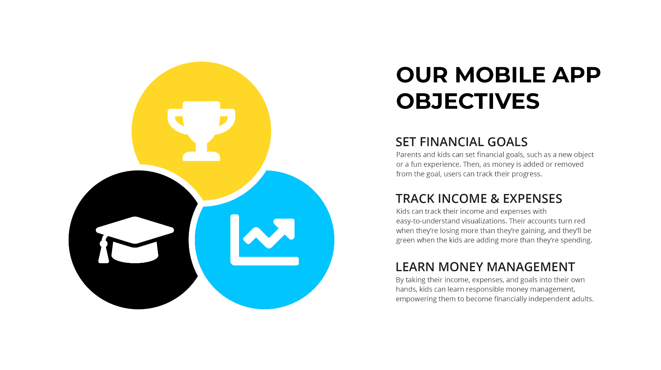

THE RESULTS:
The app, which was started from scratch, is fully developed and ready to be deployed for users. Our client is currently working through the final edits of his book. He is making changes that will align the book’s content with the model that is used in the app, so readers can use them together seamlessly. We are excited to see how the combination of the book and app can prepare children for a financially independent future, and we’re proud to offer parents a fun and interactive way to teach their kids about money management

ABOUT US

Geneca is a custom software consulting company with 20+ years of experience using advanced strategies to help clients stay ahead of their competition. At Geneca, we know that software isn’t one size fits all. We explore your unique needs and identify the right solution to accomplish your goals. We create lasting, solid partnerships with our clients and work together to design revolutionary products that engage users, transform industries, and evolve with your business.
Let’s Talk! Email us at Sales@geneca.com Call us at (630) 599-0900

